2D-Vector calculation
vec_1 dq 1.5, 2.5
vec_2 dq 3.5, 4.2
[1.5, 2.5] + [3.5, 4.2] = [5.0, 6.7]
Packed values
What are packed values?
Packed values are multiple smaller values in a single register or in memory.
vec_1 dq 1.5 , 2.5 ; Two quadwords in one variable = 128 bits in total
Packed values in memory (vec_1 variable):
00007FF6ED3C3010 00 00 00 00 00 00 F8 3F 00 00 00 00 00 00 04 40
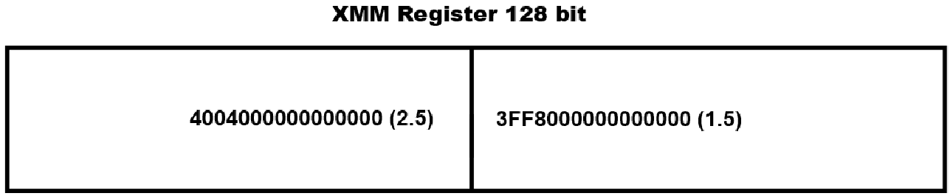
How to move a packed value in a XMM register
For simplicity we use the vmovupd (VEX.128.66.0F.WIG Move Unaligned Packed Double Precision Floating-Point Values) instructions to move a packed value into an XMM register. Then we don´t need to align the memory addresses. However that can cost some performance but it will not lead to a seriouse problem in terms of a program crash.
Keyword: Cache Line Splits
Page: 133, Section: 6.8.3.5 Cache Line Splits and Alignment
https://www.intel.com/content/www/us/en/content-details/821614/optimizing-earlier-generations-of-intel-64-and-ia-32-processor-architectures-throughput-and-latency.html

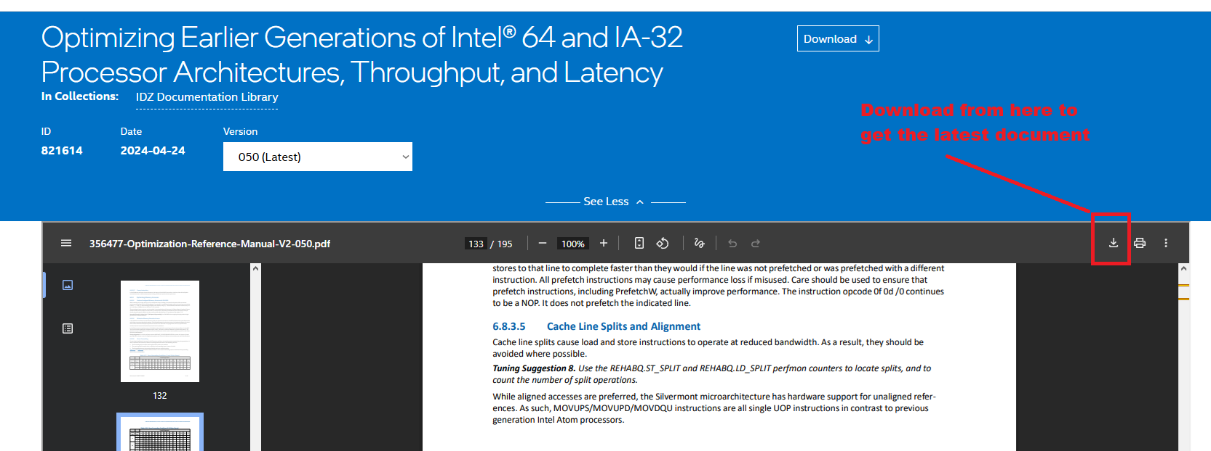
The following vmovupd combinations are allowed:
vmovupd xmm0, [vec_1] ; From memory to register.
vmovupd [vec_1], xmm0 ; From register to memory.
vmovupd xmm0, xmm1 ; From register to register.
How to calculate the vector
We are going to use the vaddpd (VEX.128.66.0F.WIG 58 Add Packed Double Precision Floating-Point Values) instruction.
Alternative instruction: addpd (Add Packed Double Precision Floating-Point Values)
addpd overwrites the data in xmm0 register:
vmovupd xmm0, [vec_1]
vmovupd xmm1, [vec_2]
addpd xmm0 xmm1
vaddpd is using the VEX encoding therefore it can preserve the data in xmm0 and xmm1:
vmovupd xmm0, [vec_1]
vmovupd xmm1, [vec_2]
vaddpd xmm2, xmm1, xmm0 ; It calculates: xmm2 = xmm1 + xmm0
addpd is using the ModRM encoding therefore there is only space for one destination and one source register.
vaddpd is using the VEX encoding and that allows us to use one destination and two source registers.
vaddpd xmm2, xmm1, xmm0
The following vaddpd combinations are allowed:
vaddpd register, register, register
vaddpd register, register, [memory]

